Задания

1. Постройте кольцевой маршрут через все пункты с минимальными затратами. Данные – стоимости проезда. 13 баллов
2. Данные – исходный план комплекса работ: времена выполнения работ. Составьте план Х перемещения ресурсов с одних работ на другие с целью минимизации времени выполнения проекта. 12 баллов

Sum X =0, t=to – bX, b=0,1, ограничения Х +2, -2.

1. Отклонения времени выполнения работы от запланированной подчиняются закону нормального распределения с СКО=1. Постройте гистограмму частотного распределения времени окончания проекта. 10 баллов
2. Разработайте проект в соответствии с этапами, описанными в Главе 1. Примерные темы в конце главы, но придумайте что-нибудь поинтереснее. 10 баллов
3. Составьте портфель Марковица из 4 ценных бумаг с положительным ростом. Данные возьмите из Интернета, по 100-150 уровней цен. 15 баллов

**Графы и данные к заданиям.**

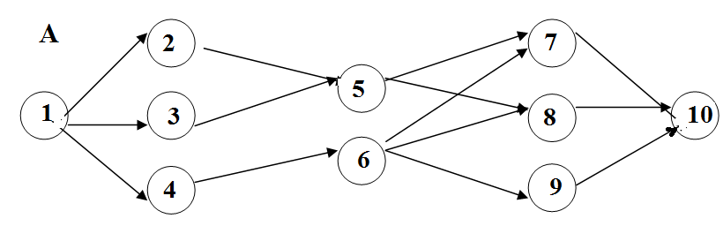

1.

|  |  |  |  |  |  |  |
| --- | --- | --- | --- | --- | --- | --- |
| Т(1,2) | Т(1,3) | Т(1,4) | Т(2,5) | Т(3,6) | Т(4,6) | Т(5,7) |
| 9 | 10 | 14 | 8 | 7 | 7 | 6 |
| Т(5,8) | Т(6,7) | Т(6,8) | Т(6,9) | Т(7,10) | Т(8,10) | Т(9,10) |
| 10 | 7 | 6 | 4 | 9 | 5 | 11 |

2.

|  |  |  |  |  |  |  |
| --- | --- | --- | --- | --- | --- | --- |
| Т(1,2) | Т(1,3) | Т(1,4) | Т(2,5) | Т(3,6) | Т(4,6) | Т(5,7) |
| 8 | 11 | 13 | 7 | 6 | 8 | 7 |
| Т(5,8) | Т(6,7) | Т(6,8) | Т(6,9) | Т(7,10) | Т(8,10) | Т(9,10) |
| 11 | 9 | 10 | 8 | 7 | 7 | 5 |

3.

|  |  |  |  |  |  |  |
| --- | --- | --- | --- | --- | --- | --- |
| Т(1,2) | Т(1,3) | Т(1,4) | Т(2,5) | Т(3,5) | Т(4,6) | Т(5,7) |
| 7 | 12 | 12 | 6 | 5 | 9 | 8 |
| Т(5,8) | Т(6,7) | Т(6,8) | Т(6,9) | Т(7,10) | Т(8,10) | Т(9,10) |
| 6 | 13 | 11 | 5 | 14 | 10 | 9 |

4.

|  |  |  |  |  |  |  |
| --- | --- | --- | --- | --- | --- | --- |
| Т(1,2) | Т(1,3) | Т(1,4) | Т(2,5) | Т(3,6) | Т(4,6) | Т(5,6) |
| 6 | 13 | 11 | 5 | 14 | 10 | 9 |
| Т(5,8) | Т(6,7) | Т(6,8) | Т(6,9) | Т(7,10) | Т(8,10) | Т(9,10) |
| 7 | 12 | 12 | 6 | 5 | 9 | 8 |

5.

|  |  |  |  |  |  |  |
| --- | --- | --- | --- | --- | --- | --- |
| Т(1,2) | Т(1,3) | Т(1,4) | Т(2,5) | Т(3,6) | Т(4,6) | Т(5,6) |
| 5 | 14 | 10 | 14 | 13 | 11 | 10 |
| Т(5,8) | Т(6,7) | Т(6,8) | Т(6,9) | Т(7,10) | Т(8,10) | Т(9,10) |
| 11 | 15 | 9 | 13 | 12 | 12 | 11 |

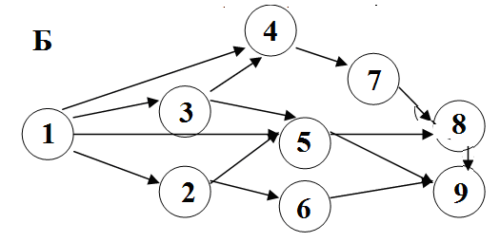

1.

|  |  |  |  |  |  |  |
| --- | --- | --- | --- | --- | --- | --- |
| Т(1,2) | Т(1,3) | Т(1,4) | Т(1,6) | Т(2,5) | Т(2,6) | Т(3,4) |
| 11 | 15 | 9 | 13 | 12 | 12 | 11 |
| Т(3,6) | Т(4,7) | Т(5,8) | Т(6,8) | Т(6,9) | Т(7,9) | Т(8,9) |
| 5 | 14 | 10 | 14 | 13 | 11 | 10 |

2.

|  |  |  |  |  |  |  |
| --- | --- | --- | --- | --- | --- | --- |
| Т(1,2) | Т(1,3) | Т(1,4) | Т(1,6) | Т(2,5) | Т(2,6) | Т(3,4) |
| 13 | 16 | 8 | 12 | 11 | 12 | 13 |
| Т(3,6) | Т(4,7) | Т(5,8) | Т(6,8) | Т(6,9) | Т(7,9) | Т(8,9) |
| 12 | 17 | 7 | 11 | 10 | 14 | 13 |

3.

|  |  |  |  |  |  |  |
| --- | --- | --- | --- | --- | --- | --- |
| Т(1,2) | Т(1,3) | Т(1,4) | Т(1,6) | Т(2,5) | Т(2,6) | Т(3,4) |
| 12 | 17 | 7 | 11 | 10 | 14 | 13 |
| Т(3,6) | Т(4,7) | Т(5,8) | Т(6,8) | Т(6,9) | Т(7,9) | Т(8,9) |
| 13 | 16 | 8 | 12 | 11 | 12 | 13 |

4.

|  |  |  |  |  |  |  |
| --- | --- | --- | --- | --- | --- | --- |
| Т(1,2) | Т(1,3) | Т(1,4) | Т(1,6) | Т(2,5) | Т(2,6) | Т(3,4) |
| 11 | 18 | 6 | 10 | 11 | 15 | 14 |
| Т(3,6) | Т(4,7) | Т(5,8) | Т(6,8) | Т(6,9) | Т(7,9) | Т(8,9) |
| 10 | 19 | 5 | 11 | 12 | 16 | 14 |

5.

|  |  |  |  |  |  |  |
| --- | --- | --- | --- | --- | --- | --- |
| Т(1,2) | Т(1,3) | Т(1,4) | Т(1,6) | Т(2,5) | Т(2,6) | Т(3,4) |
| 10 | 19 | 5 | 11 | 12 | 16 | 14 |
| Т(3,6) | Т(4,7) | Т(5,8) | Т(6,8) | Т(6,9) | Т(7,9) | Т(8,9) |
| 11 | 18 | 6 | 10 | 11 | 15 | 14 |

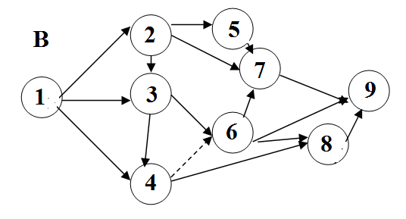

1.

|  |  |  |  |  |  |  |  |
| --- | --- | --- | --- | --- | --- | --- | --- |
| Т(1,2) | Т(1,3) | Т(1,4) | Т(2,3) | Т(2,5) | Т(2,7) | Т(3,4) | T(3,6) |
| 11 | 20 | 14 | 12 | 13 | 18 | 17 | 10 |
| Т(4,6) | Т(4,8) | Т(5,7) | Т(6,7) | Т(6,8) | Т(6,9) | Т(7,9) | Т(8,9) |
| 0 | 21 | 13 | 13 | 14 | 17 | 15 | 11 |

2.

|  |  |  |  |  |  |  |  |
| --- | --- | --- | --- | --- | --- | --- | --- |
| Т(1,2) | Т(1,3) | Т(1,4) | Т(2,3) | Т(2,5) | Т(2,7) | Т(3,4) | T(3,6) |
| 11 | 20 | 14 | 12 | 13 | 18 | 17 | 8 |
| Т(4,6) | Т(4,8) | Т(5,7) | Т(6,7) | Т(6,8) | Т(6,9) | Т(7,9) | Т(8,9) |
| 0 | 20 | 14 | 12 | 13 | 18 | 17 | 16 |

3.

|  |  |  |  |  |  |  |  |
| --- | --- | --- | --- | --- | --- | --- | --- |
| Т(1,2) | Т(1,3) | Т(1,4) | Т(2,3) | Т(2,5) | Т(2,7) | Т(3,4) | T(3,6) |
| 18 | 13 | 22 | 12 | 14 | 5 | 20 | 14 |
| Т(4,6) | Т(4,8) | Т(5,7) | Т(6,7) | Т(6,8) | Т(6,9) | Т(7,9) | Т(8,9) |
| 0 | 10 | 19 | 5 | 11 | 12 | 16 | 14 |

4.

|  |  |  |  |  |  |  |  |
| --- | --- | --- | --- | --- | --- | --- | --- |
| Т(1,2) | Т(1,3) | Т(1,4) | Т(2,3) | Т(2,5) | Т(2,7) | Т(3,4) | T(3,6) |
| 14 | 23 | 11 | 5 | 6 | 7 | 20 | 5 |
| Т(4,6) | Т(4,8) | Т(5,7) | Т(6,7) | Т(6,8) | Т(6,9) | Т(7,9) | Т(8,9) |
| 0 | 13 | 22 | 12 | 14 | 5 | 9 | 4 |

5.

|  |  |  |  |  |  |  |  |
| --- | --- | --- | --- | --- | --- | --- | --- |
| Т(1,2) | Т(1,3) | Т(1,4) | Т(2,3) | Т(2,5) | Т(2,7) | Т(3,4) | T(3,6) |
| 5 | 24 | 10 | 6 | 7 | 21 | 15 | 14 |
| Т(4,6) | Т(4,8) | Т(5,7) | Т(6,7) | Т(6,8) | Т(6,9) | Т(7,9) | Т(8,9) |
| 0 | 25 | 11 | 15 | 7 | 8 | 7 | 9 |

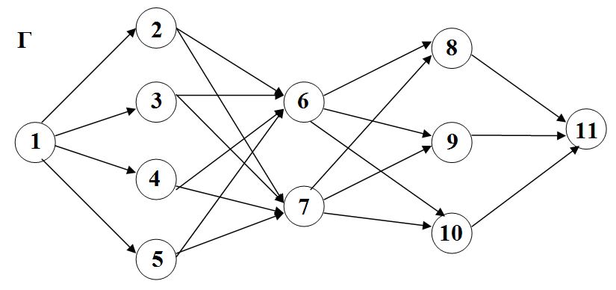

1.

|  |  |  |  |  |  |  |  |  |  |  |
| --- | --- | --- | --- | --- | --- | --- | --- | --- | --- | --- |
| Т(1,2) | Т(1,3) | Т(1,4) | Т(1,5) | Т(2,6) | Т(2,7) | Т(3,6) | Т(3,7) | Т(4,6) | Т(4,7) | Т(5,6) |
| 6 | 25 | 11 | 15 | 7 | 8 | 22 | 23 | 21 | 20 | 17 |
| Т(5,7) | Т(6,8) | Т(6,9) | Т(6,10) | Т(7,8) | Т(7,9) | Т(7,10) | Т(8,11) | Т(9,11) | Т(10,11) | |
| 5 | 24 | 10 | 6 | 7 | 21 | 20 | 9 | 10 | 11 | |

2.

|  |  |  |  |  |  |  |  |  |  |  |
| --- | --- | --- | --- | --- | --- | --- | --- | --- | --- | --- |
| Т(1,2) | Т(1,3) | Т(1,4) | Т(1,5) | Т(2,6) | Т(2,7) | Т(3,6) | Т(3,7) | Т(4,6) | Т(4,7) | Т(5,6) |
| 7 | 24 | 12 | 8 | 9 | 10 | 23 | 22 | 11 | 12 | 7 |
| Т(5,7) | Т(6,8) | Т(6,9) | Т(6,10) | Т(7,8) | Т(7,9) | Т(7,10) | Т(8,11) | Т(9,11) | Т(10,11) | |
| 14 | 26 | 8 | 23 | 13 | 9 | 10 | 24 | 23 | 12 | |

3.

|  |  |  |  |  |  |  |  |  |  |  |
| --- | --- | --- | --- | --- | --- | --- | --- | --- | --- | --- |
| Т(1,2) | Т(1,3) | Т(1,4) | Т(1,5) | Т(2,6) | Т(2,7) | Т(3,6) | Т(3,7) | Т(4,6) | Т(4,7) | Т(5,6) |
| 14 | 26 | 8 | 23 | 13 | 9 | 10 | 24 | 23 | 5 | 7 |
| Т(5,7) | Т(6,8) | Т(6,9) | Т(6,10) | Т(7,8) | Т(7,9) | Т(7,10) | Т(8,11) | Т(9,11) | Т(10,11) | |
| 7 | 24 | 12 | 8 | 9 | 10 | 23 | 22 | 11 | 10 | |

4.

|  |  |  |  |  |  |  |  |  |  |  |
| --- | --- | --- | --- | --- | --- | --- | --- | --- | --- | --- |
| Т(1,2) | Т(1,3) | Т(1,4) | Т(1,5) | Т(2,6) | Т(2,7) | Т(3,6) | Т(3,7) | Т(4,6) | Т(4,7) | Т(5,6) |
| 9 | 11 | 14 | 10 | 24 | 25 | 13 | 14 | 12 | 9 | 6 |
| Т(5,7) | Т(6,8) | Т(6,9) | Т(6,10) | Т(7,8) | Т(7,9) | Т(7,10) | Т(8,11) | Т(9,11) | Т(10,11) | |
| 10 | 11 | 20 | 5 | 17 | 7 | 15 | 13 | 16 | 22 | |

5.

|  |  |  |  |  |  |  |  |  |  |  |
| --- | --- | --- | --- | --- | --- | --- | --- | --- | --- | --- |
| Т(1,2) | Т(1,3) | Т(1,4) | Т(1,5) | Т(2,6) | Т(2,7) | Т(3,6) | Т(3,7) | Т(4,6) | Т(4,7) | Т(5,6) |
| 10 | 11 | 20 | 5 | 17 | 7 | 15 | 13 | 16 | 18 | 10 |
| Т(5,7) | Т(6,8) | Т(6,9) | Т(6,10) | Т(7,8) | Т(7,9) | Т(7,10) | Т(8,11) | Т(9,11) | Т(10,11) | |
| 9 | 11 | 14 | 10 | 24 | 25 | 13 | 14 | 12 | 21 | |

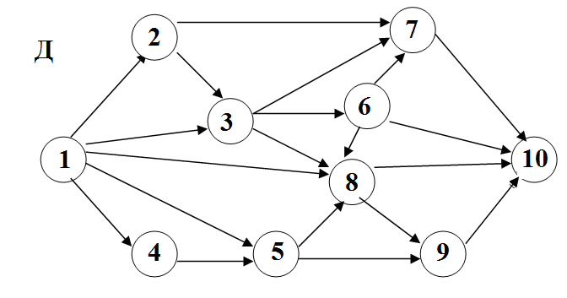

1.

|  |  |  |  |  |  |  |  |  |  |
| --- | --- | --- | --- | --- | --- | --- | --- | --- | --- |
| Т(1,2) | Т(1,3) | Т(1,4) | Т(1,5) | Т(1,7) | Т(2,4) | Т(2,8) | Т(3,5) | Т(4,6) | Т(4,7) |
| 10 | 11 | 20 | 5 | 17 | 7 | 15 | 14 | 13 | 8 |
| Т(4,8) | Т(5,7) | Т(5,9) | Т(6,7) | Т(6,8) | Т(6,10) | Т(7,9) | Т(7,10) | Т(8,10) | Т(9꟩10) |
| 9 | 11 | 14 | 10 | 24 | 25 | 13 | 3 | 6 | 9 |

2.

|  |  |  |  |  |  |  |  |  |  |
| --- | --- | --- | --- | --- | --- | --- | --- | --- | --- |
| Т(1,2) | Т(1,3) | Т(1,4) | Т(1,5) | Т(1,7) | Т(2,4) | Т(2,8) | Т(3,5) | Т(4,6) | Т(4,7) |
| 9 | 11 | 14 | 10 | 24 | 25 | 13 | 14 | 13 | 18 |
| Т(4,8) | Т(5,7) | Т(5,9) | Т(6,7) | Т(6,8) | Т(6,10) | Т(7,9) | Т(7,10) | Т(8,10) | Т(9,10) |
| 10 | 11 | 20 | 5 | 17 | 7 | 15 | 13 | 16 | 5 |

3.

|  |  |  |  |  |  |  |  |  |  |
| --- | --- | --- | --- | --- | --- | --- | --- | --- | --- |
| Т(1,2) | Т(1,3) | Т(1,4) | Т(1,5) | Т(1,7) | Т(2,4) | Т(2,8) | Т(3,5) | Т(4,6) | Т(4,7) |
| 11 | 20 | 3 | 17 | 6 | 18 | 17 | 4 | 9 | 18 |
| Т(4,8) | Т(5,7) | Т(5,9) | Т(6,7) | Т(6,8) | Т(6,10) | Т(7,9) | Т(7,10) | Т(8,10) | Т(9,10) |
| 12 | 9 | 18 | 8 | 17 | 9 | 15 | 13 | 12 | 6 |

4.

|  |  |  |  |  |  |  |  |  |  |
| --- | --- | --- | --- | --- | --- | --- | --- | --- | --- |
| Т(1,2) | Т(1,3) | Т(1,4) | Т(1,5) | Т(1,7) | Т(2,4) | Т(2,8) | Т(3,5) | Т(4,6) | Т(4,7) |
| 12 | 9 | 18 | 8 | 17 | 9 | 15 | 13 | 12 | 9 |
| Т(4,8) | Т(5,7) | Т(5,9) | Т(6,7) | Т(6,8) | Т(6,10) | Т(7,9) | Т(7,10) | Т(8,10) | Т(9,10) |
| 11 | 20 | 3 | 17 | 6 | 18 | 17 | 4 | 7 | 3 |

5.

|  |  |  |  |  |  |  |  |  |  |
| --- | --- | --- | --- | --- | --- | --- | --- | --- | --- |
| Т(1,2) | Т(1,3) | Т(1,4) | Т(1,5) | Т(1,7) | Т(2,4) | Т(2,8) | Т(3,5) | Т(4,6) | Т(4,7) |
| 13 | 11 | 23 | 8 | 7 | 18 | 17 | 14 | 22 | 18 |
| Т(4,8) | Т(5,7) | Т(5,9) | Т(6,7) | Т(6,8) | Т(6,10) | Т(7,9) | Т(7,10) | Т(8,10) | Т(9,10) |
| 14 | 19 | 11 | 18 | 17 | 7 | 15 | 9 | 14 | 20 |

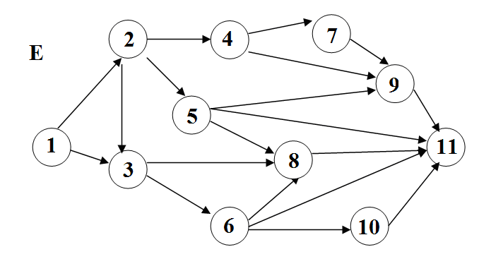

1.

|  |  |  |  |  |  |  |  |  |  |  |
| --- | --- | --- | --- | --- | --- | --- | --- | --- | --- | --- |
| Т(1,2) | Т(1,3) | Т(2,3) | Т(2,4) | Т(2,5) | Т(3,6) | Т(3,7) | Т(4,8) | Т(4,9) | Т(5,7) | |
| 4 | 9 | 8 | 6 | 7 | 5 | 3 | 9 | 4 | 6 | |
| Т(5,9) | Т(5,11) | Т(6,7) | Т(6,10) | Т(6,11) | Т(7,11) | Т(8,9) | Т(9,11) | Т(10,11) |  |
| 5 | 2 | 11 | 15 | 8 | 7 | 5 | 7 | 4 |  |

2.

|  |  |  |  |  |  |  |  |  |  |  |
| --- | --- | --- | --- | --- | --- | --- | --- | --- | --- | --- |
| Т(1,2) | Т(1,3) | Т(2,3) | Т(2,4) | Т(2,5) | Т(3,6) | Т(3,7) | Т(4,8) | Т(4,9) | Т(5,7) | |
| 20 | 15 | 10 | 16 | 17 | 8 | 15 | 13 | 12 | 9 | |
| Т(5,9) | Т(5,11) | Т(6,7) | Т(6,10) | Т(6,11) | Т(7,11) | Т(8,9) | Т(9,11) | Т(10,11) |  |
| 15 | 21 | 11 | 14 | 11 | 20 | 3 | 17 | 6 |  |

3.

|  |  |  |  |  |  |  |  |  |  |  |
| --- | --- | --- | --- | --- | --- | --- | --- | --- | --- | --- |
| Т(1,2) | Т(1,3) | Т(2,3) | Т(2,4) | Т(2,5) | Т(3,6) | Т(3,7) | Т(4,8) | Т(4,9) | Т(5,7) | |
| 16 | 21 | 10 | 18 | 8 | 10 | 5 | 13 | 16 | 11 | |
| Т(5,9) | Т(5,11) | Т(6,7) | Т(6,10) | Т(6,11) | Т(7,11) | Т(8,9) | Т(9,11) | Т(10,11) |  |
| 20 | 15 | 10 | 15 | 21 | 11 | 14 | 11 | 19 |  |

4.

|  |  |  |  |  |  |  |  |  |  |  |
| --- | --- | --- | --- | --- | --- | --- | --- | --- | --- | --- |
| Т(1,2) | Т(1,3) | Т(2,3) | Т(2,4) | Т(2,5) | Т(3,6) | Т(3,7) | Т(4,8) | Т(4,9) | Т(5,7) | |
| 14 | 19 | 11 | 18 | 17 | 7 | 7 | 14 | 13 | 8 | |
| Т(5,9) | Т(5,11) | Т(6,7) | Т(6,10) | Т(6,11) | Т(7,11) | Т(8,9) | Т(9,11) | Т(10,11) |  |
| 11 | 9 | 13 | 12 | 9 | 6 | 5 | 3 | 6 |  |

5.

|  |  |  |  |  |  |  |  |  |  |  |
| --- | --- | --- | --- | --- | --- | --- | --- | --- | --- | --- |
| Т(1,2) | Т(1,3) | Т(2,3) | Т(2,4) | Т(2,5) | Т(3,6) | Т(3,7) | Т(4,8) | Т(4,9) | Т(5,7) | |
| 15 | 21 | 11 | 14 | 11 | 18 | 7 | 14 | 13 | 18 | |
| Т(5,9) | Т(5,11) | Т(6,7) | Т(6,10) | Т(6,11) | Т(7,11) | Т(8,9) | Т(9,11) | Т(10,11) |  |
| 10 | 9 | 19 | 8 | 17 | 13 | 12 | 9 | 9 |  |